Paul Fralix, 07/06/2025, Assignment 9.2

**API connection test**

**Astronauts API program**

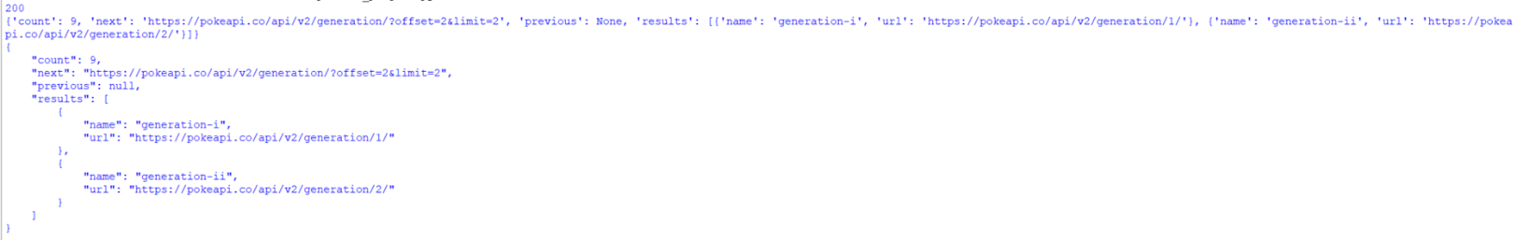**PokeAPI**